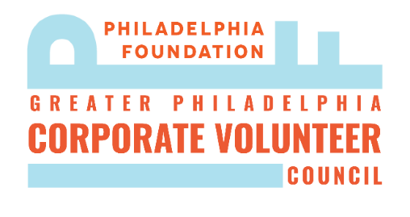

Distinguished Corporate Volunteer Awards Nomination Form
Nominator Information:
- First and Last Name
- Phone Number
- Email Address
- What is your relationship to the nominee?
- How did you hear about these awards?

Nominee Information:
- Nominee’s First and Last Name
- Nominee’s Phone Number
- Nominee’s Email Address

I am nominating this individual for the following award (Select One):
❏ Distinguished Corporate Skills-Based Volunteer: Employees of a Greater Philadelphia Company, who have advanced the mission of a Greater Philadelphia nonprofit, though their technical skills and expertise.
❏ Distinguished Corporate Volunteer (Small Company) –2000 employees or fewer: Employees of a Greater Philadelphia Company with less than 2000 employees, who have gone above & beyond their fellow employees in their companies’ respective employee engagement programs.
❏ Distinguished Corporate Volunteer (Large Company) – 2001 employees or more: Employees of a Greater Philadelphia Company with more than 2001 employees, who have gone above & beyond their fellow employees in their companies’ respective employee engagement programs.

Description of the Nominee’s Volunteer Service:

- Describe the nominee's commitment to volunteer service:

- Describe the relevance and urgency of the nominee's volunteer service to Philadelphia:

- Describe the nominee's impact on the community:

- Beyond what you have indicated in the previous questions, describe why the nominee should be recognized by Mayor Kenney:
- If possible, years the employee has worked at the Corporation:
- After the Awardees are selected, the Mayor’s office creates short videos of the winners to show at the award ceremony. Please provide as many photos as possible of the nominee in their volunteering capacity with this application. Additionally, if selected the nominee would be asked to participate in a video interview after being selected.

Return completed nominations forms to gpcvc@philafound.org by Friday January 29th.

