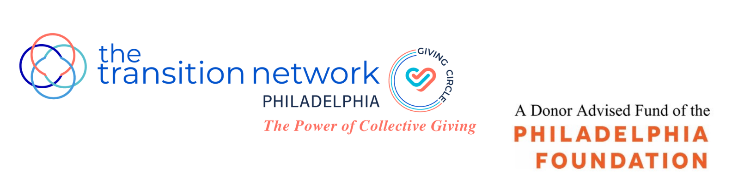

Fully completed applications are due by 5 pm., Friday, February 25, 2022

TTN Philadelphia Giving Circle
Grant Application 2022
General Operating Support

TTN Philadelphia Giving Circle, the philanthropic arm of the Philadelphia Chapter of The Transition Network (TTN), and a Philadelphia Foundation Donor Advised Fund, is pleased to announce that it is now accepting grant applications from Philadelphia nonprofit organizations which serve the needs of women and children in Philadelphia. We will award three grants this year, each $22,000. The grants are unrestricted and may be used for general operating support.

TTN Philadelphia Giving Circle is committed to inclusion across race, gender, age, religion and identity. We are looking for organizations who share this commitment.

TTN Philadelphia Giving Circle Mission:
The mission of TTN Philadelphia Giving Circle is to improve the lives of women and children in Philadelphia. Giving Circle members pool dollars, make grants to nonprofit organizations and conduct educational programs and other initiatives to raise awareness of the significant needs in our city. We are passionate about making a difference, nurturing relationships with the organizations we support and engaging with our members to build a better community.

Criteria:
Applicant organizations must meet the following criteria:
- Located in Philadelphia
- Serve Philadelphia women and/or children
- Have a 501(c)(3) public charity exempt status from the IRS
- Been in existence for a minimum of three years
- Have a general operating budget of $2 million or less
- Have not received a grant from TTN Philadelphia Giving Circle in the past 3 years

Exclusions:
The following are excluded from receiving TTN Philadelphia Giving Circle funds:
- Individuals
- Government agencies
- Organizations that promote a particular religious or political ideology
- The Transition Network, Inc. (TTN) or any of its chapters
- Endowment or capital projects or campaigns
- Speaker fees, galas or other fundraising events.

APPLICANT INFORMATION

Name of Organization:

Address:

Website:

Executive Director:

Phone: Email:

Primary Contact: Title:
(if different than above)
Phone: E-Mail:
(if different than above)

How did you hear about this grant?

APPLICANT INFORMATION (continued)

Please provide the following documents, numbering your responses and attachments to correspond to the required information.

A. Organizational:
- Mission statements.
- 501 (c)(3) designation letter from the IRS.
- List of key staff members, including previous experience, demographic data (i.e. age, race, sex, job title) and length of service.
- Most recent strategic plan, if available.

B: Governance:
- List of Board of Directors, including, relevant experience, demographics, length of service and contact information.
- List of officers and their terms.

C: Financial:
- Audited financial statements from the past 3 years. If audits are not conducted, 2 years of reviewed or compiled financial statements and/or IRS form 990s are acceptable.
- List of your 3 to 5 largest grantors and associated amounts for the last fiscal year.
- Current fiscal year budget and most recent performance year to date.

D: Impact:
- Metrics which you use to measure your success, ideally for the past 3 years (i.e. provide the measurements such as number of clients served, meals delivered, etc.).
- Provide any longer-term outcome measurements you track (i.e. increase in reading levels, job placements, etc.).

PROPOSAL NARRATIVE
(Maximum length of 4 pages, single spaced.)

This is your opportunity to help us understand why your organization. Why is it best suited and most worthy of receiving our general operating support funds? How does your work further the mission of TTN Philadelphia Giving Circle? Please respond to the following points:

1. A brief history of your organization and its long-term vision and goals.

2. Your primary programs, how these programs help you fulfill your mission, what problem(s) or need(s) these programs seek to address, what constituencies (demographics, size, geography, etc.) these programs target.

3. Recent successes, including any programs for which you are particularly proud; recent challenges, including how you intend to meet those challenges.

4. How your organization measures and evaluates your impact, citing any examples of how you have applied learnings from evaluations to adjust programs and operations.

5. Additional information which you feel is important to include.

SUPPORTING DOCUMENTATION

Please provide any other materials which you would like to share in support of your application (i.e. annual report, newsletters, press materials, etc.).

AGREEMENT

I certify, to the best of my knowledge, that all information included in this proposal is correct. The tax-exempt status of this organization is still in effect. If a grant is awarded to this organization, the proceeds of that grant will not be distributed or used to benefit any organization or individual supporting or engaged in unlawful activities.

___________________________ ________________
Signature of Executive Director Date

DIRECTIONS FOR SUBMISSION

Grant applications must include fully completed:
- Applicant information (as outlined above)
- Proposal narrative (as outlined above)
- Supporting documentation (as desired by applicant)
- Agreement signed and dated by Executive Director

Deadlines and Important Dates:
- Friday, February 25, 2022: Completed applications must be received by 5:00 pm.
- April 13 – 29, 2022: Site visits will be conducted.
- Wednesday, May 4, 2022: Finalists will be contacted.
- Thursday, May 19, 2022, evening: Finalists are required to give a brief presentation to TTN Philadelphia Giving Circle members, prior to voting.
- Friday, May 20, 2022: Grant recipients will be announced.
Please note that the grant recipients will be asked to speak at a few TTN Philadelphia Giving Circle events throughout the year.

Note: A Grant Writing Workshop for potential grant applicants will be held on Tuesday, February 1, 2022 at 10 am. Offering grant writing assistance, this session will explain our process, review expectations and present you with an overview of our grant application. We hope you will join us. To sign up, please email your contact information to Ann Lipshutz at ttnphlgivingcirclegrants@gmail.com by Friday, January 28, 2022.

Email all questions and fully-completed applications to ttnphlgivingcirclegrants@gmail.com

