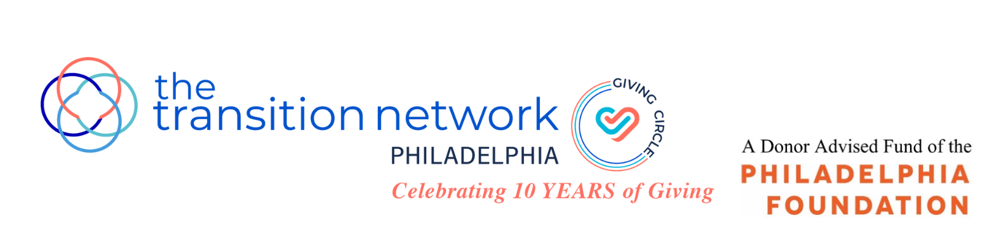
Fully completed applications are due by 5 pm., Friday, February 17, 2023

TTN Philadelphia Giving Circle
10th Anniversary “The Year of the Child"
Grant Application 2023

TTN Philadelphia Giving Circle is the philanthropic arm of the Philadelphia Chapter of The Transition Network (TTN), and a Philadelphia Foundation Donor Advised Fund. We are pleased to announce that this year, we will be awarding four grants of $30,000 each from funds raised during a 2022 year-long initiative, “The Year of the Child”, which commemorated our Giving Circle’s ten years of giving. The grants are unrestricted and may be used for general operating support.

This year, we are focusing exclusively on the needs of Philadelphia’s children and will be accepting grant applications only from Philadelphia nonprofit organizations which primarily serve, enrich and enhance the health, safety and well-being of children in Philadelphia in areas including, but not limited to, arts and culture, economic empowerment, education, environment, food access, health and wellness, housing, law and justice.

The mission of TTN Philadelphia Giving Circle is to improve the lives of women and children in Philadelphia. Giving Circle members pool dollars, make grants to nonprofit organizations and conduct educational programs and other initiatives to raise awareness of the significant needs in our city. We are passionate about making a difference, nurturing relationships with the organizations we support and engaging with our members to build a better community. TTN Philadelphia Giving Circle is committed to inclusion across race, gender, age, religion and identity. We are looking to support organizations who share this commitment.

Applicant organizations must meet the following criteria:
- Provide direct and primary services to boys and/or girls from infancy to age 21
- At least 50% of the children served must reside in Philadelphia
- Have a 501(c)(3) public charity exempt status from the IRS or a fiscal sponsorship confirmation for a minimum of two years
- Have a general operating budget for the most recent fiscal year end of $2 million or less
- Have not received a grant from TTN Philadelphia Giving Circle in the past 3 years
- Do not promote a particular religious or political ideology

APPLICANT INFORMATION

Name of Organization:

Address:

Website:

Executive Director:

Phone: Email:

Primary Contact: Title:
(if different than above)
Phone: E-Mail:
(if different than above)

How did you hear about the Giving Circle grants?

APPLICANT INFORMATION (continued)

Please provide the following documents, numbering your responses and attachments to correspond to the required information.

A. Organizational:
- Mission statements.
- 501 (c)(3) designation letter from the IRS or fiscal sponsorship confirmation letter.
- List of key staff members, including previous experience, demographic data (i.e. age, race, sex, job title) and length of service.
- Most recent strategic plan, if available.

B: Governance:
- List of Board of Directors, including, relevant experience, demographics, length of service and contact information.
- List of officers and their terms.

C: Financial:
- Audited financial statements from the past 2 years. If audits are not conducted, 2 years of reviewed or compiled financial statements and/or IRS form 990s are acceptable.
- If your most recent audit is more than 15 months old, provide internally prepared operating results for the most recent fiscal year end.
- Current fiscal year budget and most recent performance year to date.
- If you operate under a fiscal sponsorship, provide a copy of the Memorandum of Understanding with the sponsor and 2 years of internally prepared fiscal year end statements of your individual organization.
- List of your 3 to 5 largest grantors and associated amounts for the last fiscal year

D: Impact:
- Number and demographic profile of clients served for the past 2 years including percentage who reside in Philadelphia.
- Recent metrics which you use to measure your success and how those results confirm your organizational impact.

PROPOSAL NARRATIVE
(Maximum length of 4 pages, single spaced.)

This is your opportunity to help us understand why your organization. Why is it best suited and most worthy of receiving our general operating support funds? How does your work further the mission of TTN Philadelphia Giving Circle? Please respond to the following points:

1. A brief history of your organization and its long-term vision and goals.

2. Your primary programs, how these programs help you fulfill your mission, what problem(s) or need(s) these programs seek to address, what constituencies (demographics, size, geography, etc.) these programs target.

3. Recent successes, including any programs for which you are particularly proud; recent challenges, including how you intend to meet those challenges.

4. How your organization measures and evaluates your impact, citing any examples of how you have applied learnings from evaluations to adjust programs and operations.

5. Additional information which you feel is important to include.

SUPPORTING DOCUMENTATION

Please provide any other materials which you would like to share in support of your application (i.e. annual report, newsletters, press materials, etc.).

AGREEMENT

I certify, to the best of my knowledge, that all information included in this proposal is correct. The tax-exempt status of this organization is still in effect and all child abuse clearances including PA Child Abuse History Clearance, criminal history, and FBI fingerprinting are up to date for all program staff and volunteers working with children and youth. If a grant is awarded to this organization, the proceeds of that grant will not be distributed or used to benefit any organization or individual supporting or engaged in unlawful activities.

___________________________ ________________
Signature of Executive Director Date

DIRECTIONS FOR SUBMISSION

Grant applications must include fully completed:
- Applicant information (as outlined above)
- Proposal narrative (as outlined above)
- Supporting documentation (as desired by applicant)
- Agreement signed and dated by Executive Director

Deadlines and Important Dates:
- Friday, February 17, 2023: Completed applications must be received by 5:00 pm.
- April 5, 2023: Semi-finalists notified.
- April 17 – 28, 2023: Site visits conducted with semi-finalists.
- Friday, May 5, 2023: Finalists notified.
- Thursday, May 18, 2023, early evening: Finalists are required to give a brief presentation to TTN Philadelphia Giving Circle members, prior to voting.
- Friday, May 19, 2023: Grant recipients will be announced.

Please note that the grant recipients will be asked to provide a brief one page report at the end of the grant period and speak at a few TTN Philadelphia Giving Circle events throughout the year.

Note: A Grant Information Session for potential grant applicants will be held on Wednesday, January 25, 2023 at 10 am. This session will explain our process, review expectations and present you with an overview of our grant application. We hope you will join us. To sign up, please send your contact information to the email address below by Friday January 20, 2023.

Email all questions and fully-completed applications to: ttnphlgivingcirclegrants@gmail.com

