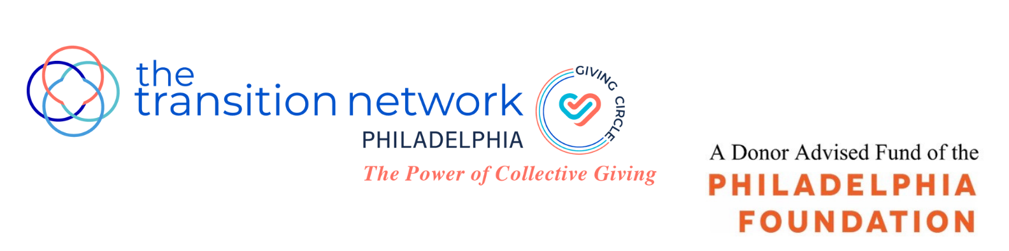
Fully completed applications are due by 5 pm., Friday, February 16, 2024

TTN Philadelphia Giving Circle
Grant Application 2024

TTN Philadelphia Giving Circle is the philanthropic arm of the Philadelphia Chapter of The Transition Network (TTN), and a Philadelphia Foundation Donor Advised Fund. We are pleased to announce that this year, we will be awarding three grants of at least $20,000 each. The grants are unrestricted and may be used for general operating support.

This year, we are focusing on children in underserved communities who have limited access to Pre-K education. Our grants will be awarded exclusively to Philadelphia nonprofit organizations whose missions expressly state and/or those that primarily offer language-based educational programs, resources and opportunities to advance and support the development of literacy skills in children from age 3 to 9 (Pre-K to Grade 4).

The TTN Philadelphia Giving Circle’s mission is to support local nonprofit organizations working to improve the lives of women and children in the City of Philadelphia by raising funds for collective donor-advised philanthropy. We are passionate about making a difference, nurturing relationships with the organizations we support and engaging with our donors to build a better community. TTN Philadelphia Giving Circle is committed to inclusion across race, gender, age, religion and identity. We are looking to support organizations who share this commitment.

Applicant organizations must meet the following criteria:
- Provide literacy and education programs to support the development of literacy skills in children from age 3 to 9 (Pre-K to Grade 4)
- Primarily serve children residing in Philadelphia
- Have a 501(c)(3) public charity exempt status from the IRS or a fiscal sponsorship confirmation for a minimum of two years
- Have a general operating budget for the most recent fiscal year end of $2 million or less
- Have not received a grant from TTN Philadelphia Giving Circle in the past 3 years
- Do not promote a particular religious or political ideology

APPLICANT INFORMATION

Name of Organization:

Address:

Website:

Executive Director:

Phone: Email:

Primary Contact: Title:
(if different than above)
Phone: E-Mail:
(if different than above)

How did you hear about the Giving Circle grants?

APPLICANT INFORMATION (continued)

Please provide the following documents, numbering your responses and attachments to correspond to the required information.

A. Organizational:
- Mission statement.
- 501 (c)(3) designation letter from the IRS or fiscal sponsorship confirmation letter.
- List of key staff members, including previous experience, demographic data (i.e. age, race, sex, job title) and length of service. Please include a resume for the Executive Director.
- Most recent strategic plan, if available.

B: Governance:
- List of Board of Directors, including designated officers, length of service, relevant experience, and demographics (either individually or as a whole).

C: Financial:
- Audited financial statements from the past 2 years. If audits are not conducted, 2 years of reviewed or compiled financial statements and/or IRS form 990s are acceptable.
- If your most recent audit is more than 15 months old, provide internally prepared operating results for the most recent fiscal year end.
- Current fiscal year budget and most recent financial performance year to date.
- If you operate under a fiscal sponsorship, provide a copy of the Memorandum of Understanding with the sponsor and 2 years of internally prepared fiscal year end statements of your individual organization.
- List of your 3 to 5 largest grantors and associated amounts for the last two fiscal years.

D: Impact:
- An approximation of the following information:
 | Prior Fiscal Year | Proposed Fiscal Year
Number of Targeted* Children Served
% who reside in Philadelphia
% BIPOC
% at or below 150% of Poverty Level
*Ages 3-9 (pre-K-grade 4)

- Recent metrics which you use to measure your success/progress in pursuit of your organizational impact.

PROPOSAL NARRATIVE
(Maximum length of 4 pages, single spaced.)

This is your opportunity to help us understand why your organization. Why is it best suited and most worthy of receiving our general operating support funds? How does your work align with our 2024 focus on advancing child literacy in underserved Philadelphia neighborhoods? Please respond to the following points:

1. A brief history of your organization and its long-term vision and goals.

2. Describe your primary programs, what problem(s) or need(s) do these programs seek to address in the community and how do these programs help you fulfill your mission.

3. Recent successes, including any programs for which you are particularly proud; recent challenges, including how you intend to meet those challenges.

4. How does your organization measure and evaluate impact, citing any examples of how you have applied learnings from evaluations to adjust programs and operations.

5. Additional information which you feel is important to include.

SUPPORTING DOCUMENTATION

Please provide any other materials which you would like to share in support of your application (i.e. annual report, newsletters, press materials, YouTube links, etc.).

AGREEMENT

I certify, to the best of my knowledge, that all information included in this proposal is correct. The tax-exempt status of this organization is still in effect and all child abuse clearances including PA Child Abuse History Clearance, criminal history, and FBI fingerprinting are up to date for all program staff and volunteers working with children and youth. If a grant is awarded to this organization, the proceeds of that grant will not be distributed or used to benefit any organization or individual supporting or engaged in unlawful activities.

___________________________ ________________
Signature of Executive Director Date

DIRECTIONS FOR SUBMISSION

Grant applications must include fully completed:
- Applicant information
- Proposal narrative
- Supporting documentation
- Agreement signed and dated by Executive Director

Deadlines and Important Dates:
- Friday, February 16, 2024: Completed applications must be received by 5:00 pm.
- Thursday, March 28, 2024: Semi-finalists notified.
- April 15 – 26, 2024: Site visits conducted with semi-finalists.
- Thursday, May 2, 2024: Finalists notified.
- Thursday, May 16, 2024, early evening: Finalists are required to give a brief presentation to TTN Philadelphia Giving Circle donors, prior to voting.
- Friday, May 17, 2024: Grant recipients notified.

Please note that the grant recipients will be asked to provide a brief one page report at the end of the grant period and speak at a few TTN Philadelphia Giving Circle events throughout the year.

Note: An Information Session for potential grant applicants will be held on Wednesday, January 24, 2024 at 10 am. This Zoom session will explain our process, review expectations and present you with an overview of our grant application. We hope you will join us. To register, please click here.

Questions and completed applications should be directed to:
ttnphlgivingcirclegrants@gmail.com

